Maximum marks for Assignment: _8 Assignment Declaration Date: 14/08/2025
Assignment Submission Date: 30/8/2025 Assignment assessment declaration Date by faculty: 30/8/2025

Question NO | Question Statement | Level of mapping & NO. |  |  | Blooms Level | Marks
Question NO | Question Statement | CO | PO | PSO | Blooms Level | Marks
Q.1 | Functions of Loader. List down different loader schemes in brief. | CO3 | PO1 |  | 1 | 2
Q.2 | Explain the design of the direct linking loader or absolute loader. | CO1,3 | PO1,3 |  | 2 | 4
Q.3 | What are the data structures used in the design of the direct linking loader? Design pass-1 of the same. | CO1,3 | PO2,3 |  | 1 | 5
Q.4 | Differentiate between the compile and go loader, and absolute loader | CO3 | PO3 |  | 4 | 4
Q.5 | Differentiate between Static and Dynamic link libraries | CO3 | PO1 |  | 1 | 3
Q.6 | What is an absolute loader? Explain the design of the absolute Loader with a suitable example and flowchart, show the text card and transfer card | CO3 | PO3 |  | 2 | 5
Q.7 | Explain formats of ESD, RLD, TXT, and END cards with respect to the direct linking loader with a suitable example? | CO3 | PO1,3 |  | 3 | 6
Q.8 | Explain the general loader scheme with advantages and disadvantages with a suitable diagram. | CO3 | PO5 |  | 2 | 8
Q.9 | What is a subroutine linkage loader? What is the benefit of using it? | CO3 | PO1 |  | 1 | 3
Q.10 | What are the types of loaders? Explain the compile and go loader with advantages and disadvantages with a diagram | CO3 | PO5 |  | 2 | 4
Q.11 | Write a short note on 1. Subroutine linkage 2. Overlays | CO3 | PO1 |  | 1 | 6
Blooms level no | Blooms Taxonomy terms
6 | 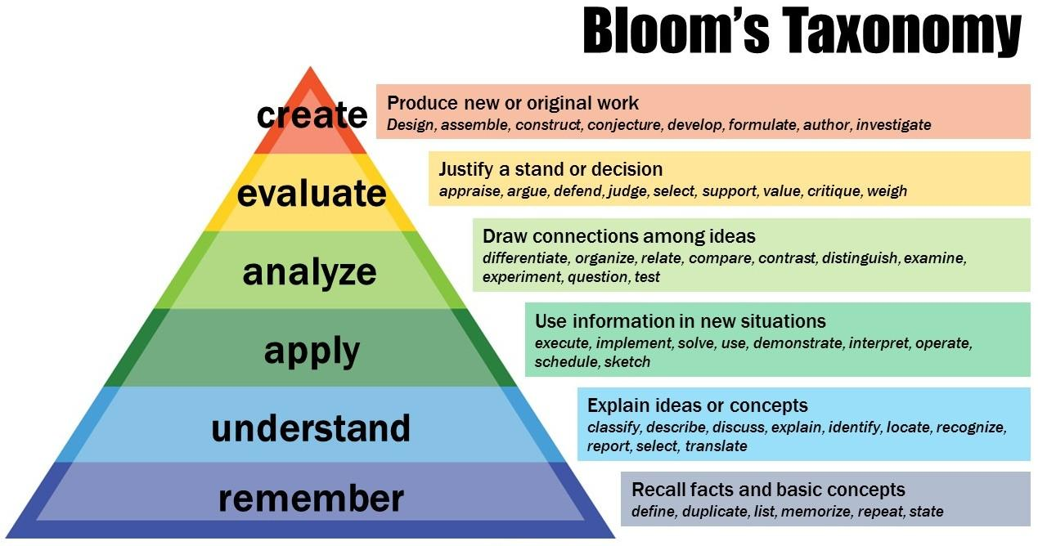
5
4
3
2
1

Subject In-charge HOD

